**Type Your Title Here**

# Abstract

The abstract should clearly outline the research objectives, scope of the study, methodology, key findings, and contributions. Close the abstract with a list of 3-5 keywords that capture the study’s main concepts and enhance discoverability in academic searches. Keep the abstract within 250 words.

# Keywords: *guides, instructions, author’s kit, conference publications*

**JEL classification codes:**

# Introduction

This format is to be used for submissions that are published in the conference proceeding. In essence, you should format your paper exactly like this document. The easiest way to do this is simply to download the template and replace the content with your material.

# Text formatting

Please format in Microsoft Word, not exceeding 7,000 words. Use Unicode encoding; a 13-pts Times New Roman font; margins: left 30mm, right 25mm, top 25mm, bottom 25mm, in which these guidelines have been set.

# Language, style, and content

The language of the manuscript is English, with spelling and punctuation from any English dialect as long as it is consistent. Hyphenation is optional. Please ensure suitability for an international audience by following these guidelines:

* Write in a straightforward style. Use simple sentence structure. Try to avoid long sentences and complex sentence structures. Use semicolons carefully.
* Use common and basic vocabulary (e.g., use the word “unusual” rather than the word “arcane”).
* Briefly define or explain all technical terms. The terminology common to your practice/discipline may be different in other design practices/disciplines.
* Spell out all acronyms the first time they are used in your text. For example, “World Wide Web (WWW)”.
* Explain local references (e.g., not everyone knows all city names in a particular country)

A manuscript could have various structure but must ensure all the necessary contents of a complete research. A scientific manuscript usually includes the following sections:

* 1. **Introduction**

The introduction should be precise and subtitle-free, outlining the research's necessity, objectives, innovations, and expected theoretical and practical contributions.

* 1. **Literature review**

This section outlines key theories and perspectives related to the manuscript and summarizes relevant studies (including authors, years, titles, methods, and results). Based on this, the authors propose a research model, analytical framework, or assumptions.

* 1. **Methodology**

Based on the proposed model, framework, or hypotheses, appropriate analytical methods are selected to ensure scientific validity. The research scope is clarified through detailed data collection methods and variable measurement. All data sources must be fully and reliably cited.

* 1. **Results**

Research findings may be derived from qualitative or quantitative analysis. Discussions should stay within the scope of the manuscript, with results directly supporting the conclusion.

* 1. **Conclusions**

This section summarizes the key findings and reaffirms the research objectives. It should explain the significance of the findings, highlight how the results contribute to theory, practice, or policy, and discuss their practical applications. The conclusion may also note limitations and suggest directions for future research.

# Figures

The examples on this and the following pages should help you get a feel for how screen-shots and other figures should be placed in the template. Figures and tables should be placed in suitable spaces. All figures should be cited in the paper in a consecutive order. *Be sure to make images large enough so the important details are legible and clear.* Your document may use colour figures, which are included in the page limit; the figures must be usable when printed in black and white. A raster format of the figure should be at least in 300dpi resolution and is better saved in PNG format rather than JPEG (a loosy compression image format).

We recommend using Photoshop or other graphics software to scale images, rather than scaling them after you have placed them in Word. Word’s scaling tends to reduce the clarity and legibility of images more so than dedicated graphics software.

The title of the figure should be placed below it. E.g:

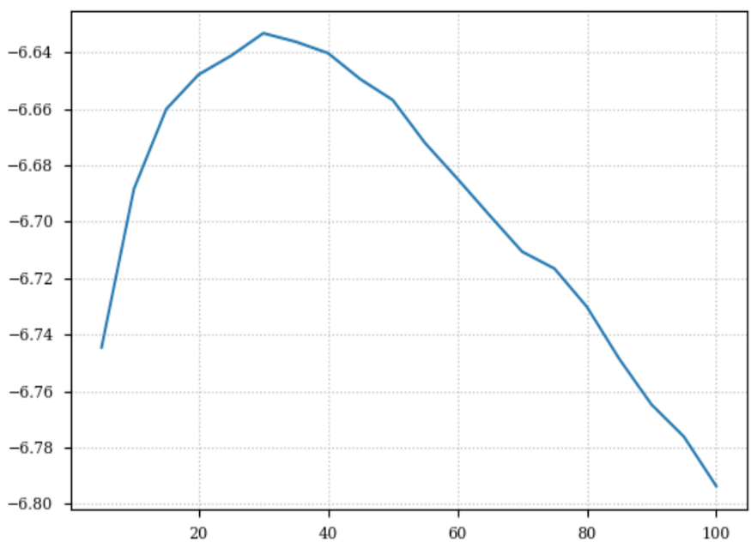

# Fig. 1: Bound of perplexity on the test set

# Tables

Every table must have a descriptive title. The table should also be centred and its title is on the top. E.g.:

**Table 1: Description of the samples**

|  |  |  |  |  |  |  |
| --- | --- | --- | --- | --- | --- | --- |
|  | | Numbers of respondents (NR) | Percentage of NR to number of TR* | Number of online banking (NOB) | Percentage of NOB to number of TA** | Percentage of NOB to NR |
| Sex | Male | 434 | 50.35% | 131 | 48.34% | 30.18% |
| female | 428 | 49.65% | 140 | 51.16% | 32.71% |

* TR denotes total respondents.

** TA denotes total adopters

# Formula and Equation

Any equations should be editable texts, not images. Equations should be numbered consecutively (numbers are in parentheses) on the right side of the page and mentioned as equations (1), (2), etc. any more complex equations should be shown using the equivalent software. In this sample, the following equations are presented as illustration:

$P(t)=\frac{b^{\frac{t+1}{T+1}}-b^{\frac{t}{T+1}}}{b-1}$ (1)

where t = 0, . . . , T, and b is a number greater than 1.

It should noted that all easily confused characters and symbols should be noticed to the proceedings editor.

1. **References and Citations**

Please format according to APA 7th edition guidelines.

The list of references places at the end of the manuscript. The authors should ensure that all sources are appropriately cited and correspond to each citation in the manuscript.

Your references should be published materials accessible to the public. Internal technical reports may be cited only if they are easily accessible (i.e., you provide the address for obtaining the report within your citation) and may be obtained by any reader for a nominal fee.

# Others

* Date is displayed in the format: DD/MM/YYYY (e.g. 25/09/2025)
* The footnotes are placed at the end of the reffered pages and numbered with Arabic numerals, font Times New Roman, size 10:

(1) One of the founding editors of *ephemera* recalls that part of *ephemera*’s motivation was to open up to authors not fully entrenched in university discourse.

# Acknowledgements

Acknowledgements should be placed prior to the references section in the manuscript.

An explicit acknowledgment should announce the contributions of all organizations and individuals who have provided funding and/or facilitated/conducted the research (with their permission). Any potential conflicts of interest should be disclosed.

Thank you for your submissions. We hope to see you in Ho Chi Minh City, Vietnam, at the conference this September.